Aquatic Vegetation Survey 2010

for Adams Lake
by

Tip of the Mitt Watershed Council

Survey performed and report written by Kevin L. Cronk

Table of Contents

Page
List of Tables and Figures iii
Summary 1
Introduction 3
Background 3
Study Area 4
Methods 7
Documenting aquatic plants at sample sites 7
Mapping aquatic plant communities 8
Data processing and map development 9
Results 11
Sample site results 11
Plant community mapping results 14
Discussion 17
General 17
Recommendations 19
Literature and Data Referenced 22

List of Tables

Page
Table 1. Adams Lake watershed land-cover statistics 2006 6
Table 2. Water quality data from Adams Lake, 2010 6
Table 3. Aquatic plant taxa occurrence at sample sites 12
Table 4. Aquatic plant densities at sample sites 12
Table 5. Dominant vegetation type statistics 14
Table 6. Dominant aquatic plant community types 15
Table 7. Aquatic plant community densities 15
Table 8. Aquatic plant survey statistics from area lakes 17

List of Figures

Page
Figure 1. Map of the Adams Lake Watershed 5
Figure 2. Map of aquatic plant densities in Adams Lake 13
Figure 3. Map of aquatic plant community types in Adams Lake 16

SUMMARY

Aquatic plants provide many benefits to aquatic ecosystems, but they can become a recreational nuisance and even affect water quality when growth is excessive. Heavy aquatic plant growth can occur naturally given the correct combination of environmental variables (e.g., light and nutrient availability), but is accelerated due to factors such as nutrient pollution or the introduction of non-native species.
Concerns regarding dense aquatic plant growth in Adams Lake (Charlevoix County, Michigan) prompted the Adams Lake Preserve Association to sponsor a comprehensive aquatic plant survey. During the summer of 2010, Tip of the Mitt Watershed Council staff collected specimens and documented plant densities at 32 sample sites throughout the lake. A total of 27 aquatic plant taxa were documented during the survey. Muskgrass (Chara spp.), common bladderwort (Utricularia vulgaris), and common watermilfoil (Myriophyllum sibircum) were the most commonly collected species, whereas muskgrass and coontail (Ceratophyllum demersum) were found to be dominant at the greatest number of sites. No invasive aquatic plant species were found during this survey.
Aquatic plant communities were delineated directly in the field using a GPS (global positioning system) or indirectly through interpolation or extrapolation of sample site data. Plant community data showed that the vast majority of Adams Lake contained aquatic vegetation (99%). Heavy-density plant growth was common throughout the lake (>75% of the lake area), with areas of light or little vegetation found only in the deeper waters in the middle of the lake and along the northern portion of the east shore. Coontail, pond-lily, and muskgrass dominated the largest portion of aquatic plant communities in terms of areal extent.
The heavy-density aquatic plant growth throughout much of Adams Lake is likely due, in part, to natural factors; namely the small size of the lake coupled with extensive shallow areas. With less than 50 acres of surface area and 18 feet of depth, Adams Lake would generally be categorized as a eutrophic lake that is approaching the end of its life span. All lakes undergo a natural aging process, wherein they gradually fill with sediments, become more biologically productive, and eventually transform into a wetland ecosystem before disappearing completely. Adam’s Lake exhibits many of these characteristics, of a lake that is becoming smaller, shallower, and more biologically productive.
Another variable that may be affecting the Adams Lake ecosystem is beaver activity on Loeb Creek. Elevated water levels from beaver dams could increase the residence time of water flowing into the lake from the inlet streams and potentially result in more nutrients being deposited in the lake. Increased lake levels and therefore, increased water volume, may dilute the lake’s nutrient concentrations, though this may be offset by an influx of nutrients from areas re-inundated by rising water levels where potentially large stores of nutrients were tied up in decomposing organic matter. Any increase in nutrient inputs could spur on additional plant growth in the lake.
Nutrient inputs from cultural (human) sources, such as fertilizers, septic leachate, and stormwater, may have increased over time, though there is not enough water quality data to substantiate such a claim. Regardless, agricultural landuse in the watershed is suspected as a nutrient source that is contributing to the prolific and dense plant growth. The land area drained by the two main inlet streams consists largely of agricultural landuse.
The Adams Lake Preserve Association should share results from this survey to maximize benefits and assist in lake management efforts. Beaver dam activity should be investigated and controlled if necessary, taking into account that the lake’s water level could drop. Agricultural landuse in the watershed should be evaluated and best management practices instituted where possible to reduce impacts.
Information and education efforts should be undertaken to promote an understanding of aquatic plant communities and the lake ecosystem among riparian property owners and other lake users, as well as encourage behaviors and practices that protect and improve lake water quality. Future surveys are recommended to collect data for determining trends over time, evaluate successes or failures of aquatic plant management projects, and for early detection of non-native aquatic plant species, which would allow for effective control through a system of rapid response.

INTRODUCTION

Background:
Aquatic plant communities provide numerous benefits to lake ecosystems. Aquatic plants provide habitat, refuge, and act as a food source for a large variety of waterfowl, fish, aquatic insects, and other aquatic organisms. Like their terrestrial counterparts, aquatic plants produce oxygen as a by-product of photosynthesis. Aquatic plants utilize nutrients in the water that would otherwise be used by algae and potentially result in nuisance algae blooms. A number of aquatic plants, including bulrush, water lily, cattails, and pickerel weed help prevent shoreline erosion by absorbing wave energy and moderating currents. Soft sediments along the lake bottom are held in place by rooted aquatic plants.
Lake systems with unhealthy or reduced aquatic plant communities could experience declining fisheries due to habitat and food source losses. Aquatic plant loss may also result in decreased daytime dissolved oxygen levels and increased shoreline erosion. If native aquatic plants are removed through harvesting or herbicide application, resistance of the naturally occurring plant community is weakened and can open the door for invasive species, such as curly-leaf pondweed or Eurasian watermilfoil.
In spite of all the benefits associated with aquatic plants, some aquatic ecosystems suffer from overabundance, particularly where non-native (i.e., invasive) species have been introduced. Excessive plant growth can create a recreational nuisance by making it difficult or undesirable to boat, fish and swim, but it also has the potential to alter the aquatic ecosystem and even degrade water quality. In lakes plagued by nuisance plant growth, it sometimes becomes necessary to develop and implement programs to control excessive growth and non-native species.
Aquatic plant management is a critical component of lake management. Thus, an important step in developing a sound lake management program is to survey the aquatic plant communities to document species, abundance, density, and the presence of non-native species. In 2010, the Adams Lake Preserve Association contracted with Tip of the Mitt Watershed Council to perform a comprehensive aquatic plant survey of Adams Lake. Survey field methods, data management procedures, project results, and discussion of results are contained in this report.

Study area:
Adams Lake is located in Marion Township in western Charlevoix County in the northwest Lower Peninsula of Michigan. Based upon digitization of aerial orthophotography (2004) acquired from the Charlevoix County GIS (Geographical Information System) Department, the Adams Lake shoreline measures 1.2 miles and the lake surface area totals 43 acres. The lake measures approximately 0.5 miles from north to south and is less than 0.25 miles at its widest point.
Adams Lake is a shallow drainage lake of glacial origin. Maps from the Michigan Department of Natural Resources (MDNR) Institute for Fisheries Research indicate that the deepest point in the lake is located near the center, reaching approximately 18 feet of depth. Inlet streams to Adams Lake include Adams Creek in the southern tip and an unnamed stream that flows in at the northeast corner. Water exits the lake in the northwest corner, forming the headwaters of Loeb Creek, which drains into the west end of Lake Charlevoix.
Based on a watershed boundary file developed by the Watershed Council in a GIS using data acquired from the State of Michigan, the Adams Lake watershed encompasses 2,225 acres, which includes the lake area (Figure 1). The watershed without the lake area totals 2,182 acres, resulting in a watershed area to lake area ratio of 50.74. This ratio provides a statistic for assessing impacts from agricultural, urban, and other development in the watershed. Adams Lake has over 50 acres of land in the watershed for each acre of the lakes’ surface area, which is a considerable buffer for moderating water quality impacts from landscape development and human activity in the watershed.
Land-cover statistics for the Adams Lake watershed were generated using data layers developed by the Coastal Services Center (NOAA) in South Carolina as part of the Coastal Great Lakes Land Cover project. Based on the Center’s 2006 data, the majority of the watershed’s landcover is natural, consisting primarily of forests and wetlands. Agricultural lands cover approximately one third of the watershed, whereas

Figure 1. Map of the Adams Lake Watershed.
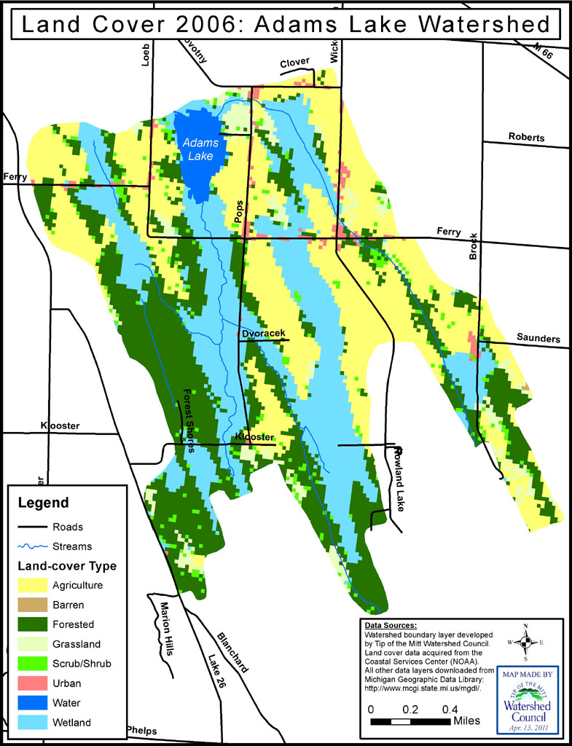

urban (residential) amounts to less than 2% (Table 1). The percentage of agricultural land-cover in the Adam’s Lake watershed is quite high for Northern Michigan.

Table 1. Adams Lake watershed land-cover statistics 2006.
Land-cover Type | Acres | Percent
Agriculture | 746.78 | 33.56
Barren | 0.55 | 0.02
Forested | 623.19 | 28.01
Grassland | 94.84 | 4.26
Scrub/Shrub | 65.23 | 2.93
Urban | 37.54 | 1.69
Water | 48.89 | 2.20
Wetland | 608.02 | 27.33
TOTAL | 2225.03 | 100.00

Water quality data for Adams Lake is very limited. The Surface Water Information Management System, available over the internet through the Michigan Department of Environmental Quality, currently contains no water quality data for Adams Lake. The only data available is that collected by Watershed Council staff during the course of this survey on July 22, 2010. Parameters monitored showed that the water quality of Adams Lake was similar to other lakes of the same size and depth in Northern Michigan. Dissolved oxygen concentrations were found to be very low near the bottom of the lake, though this is not an uncommon occurrence in small lakes during mid to late summer (Table 2).

Table 2. Water quality data from Adams Lake, 2010.
SITE | Depth (ft) | Temperature (øC) | Dissolved Oxygen (mg/l)* | Conductivity (uS/cm)* | pH | Barometric Pressure
A | 0.66 | 25.91 | 8.01 | 322.73 | 8.12 | 743.07
A | 13.45 | 18.49 | 0.21 | 470.40 | 6.86 | 743.13
B | 3.28 | 25.88 | 7.93 | 322.57 | 8.11 | 743.13
B | 6.56 | 25.85 | 7.86 | 322.73 | 8.09 | 743.27
B | 9.84 | 22.97 | 0.14 | 391.70 | 7.05 | 743.43
SITE | Depth (ft) | Chloride (mg/l)* | Nitrate-Nitrogen (ug/l)* | Soluble Phosphorus (ug/l)* | Total Phosphorus (ug/l)* | Total Nitrogen (ug/l)*
A | 0.66 | 8.8 | <1.0 | 1.9 | 10.7 | 545
A | 13.45 | 7.6 | <1.0 | 2.5 | 15.0 | 574
*units: mg/l = milligrams per liter or parts per million; ug/l = micrograms per liter or parts per billion;
uS/cm = microSiemens/centimeter.

METHODS

Field data for the Adams Lake aquatic plant survey were collected on July 21st and 22nd of 2010. Aquatic plants were documented in all lake areas that were accessible. Consistent with Michigan Department of Environmental Quality procedures, the aquatic plant communities of Adams Lake were surveyed using rake tows and through visual observations (MDEQ, 2001). After completing the field survey, data collected in the field were processed and used to produce maps displaying the lake’s aquatic plant community types and densities.

Documenting aquatic plants at sample sites:
To document aquatic plant taxa, specimens were collected, identified, photographed and recorded in a notebook at 32 sample sites throughout the lake. Sample site locations were not random, but rather selected with the intent of collecting representative information on all aquatic plant communities currently inhabiting the lake. Most sampling was conducted along transects across the lake that were spaced at regular intervals. The distance between sample points along transects varied depending upon plant community changes that were visible from the surface. In areas where plant communities were not visible, sample sites were selected based on interpretation of signals from the depth-finder or at regular intervals along the transect.
At each sample site, the boat was anchored, water depth noted, and GPS data recorded. Water depth was monitored using a Hummingbird depth finder installed on the boat. The location of each sampling station was recorded using a Trimble GeoExplorer3 GPS unit with a reported accuracy of 1-3 meters.
Plant specimens were collected using a sampling device consisting of two garden rake heads fastened together back to back with a length of rope attached. Using the sampling device, multiple throws were made at each site, collecting from all sides of the boat. Sampling continued until the collector was satisfied that all plant taxa present at the site were represented in the sample. Rigorous sampling techniques and effort were employed, but some species may have been missed.
Specimens were identified to the lowest taxonomic level possible and representative samples of each species were laid out and photographed with a slip of paper indicating the number assigned to that site. Taxon density was subjectively determined (in relation to all plant taxa collected in the sample) and recorded as light (L), moderate (M), or heavy (H), but also including the sub-categories of very light (VL), light to moderate (LM), moderate to heavy (MH) and very heavy (VH). In general, the category “very heavy” was assigned when plant growth was so heavy that it reached the surface and formed a continuous mat. At the other end of the spectrum, “very light” indicated sparse vegetation where only a few stems or pieces were found. Overall plant density for the site was determined and noted using the same categorization system.
If a specimen could not be identified immediately, it was stored in a sealed bag and identified later with the aid of taxonomic keys, mounted herbarium specimens, and, if necessary, assistance from other aquatic plant experts. All taxa names, relative taxa densities, overall site density and comments were recorded in a field notebook. If no plants were encountered during sampling, ‘no vegetation’ was recorded in the field notebook.
To assist in mapping the aquatic vegetation in Adams Lake, additional photographs were taken to document emergent vegetation. At each sample site located within or adjacent to emergent vegetation, pictures were taken of surrounding areas.

Mapping aquatic plant communities:
Plant communities can be delineated simply by interpolating or extrapolating between sample points, but the accuracy of such delineations can be greatly improved by noting and mapping precise locations where one plant community type ends and another begins. Therefore, additional data were collected to improve the accuracy of delineations between distinct plant communities in the lake. During sampling, details observed about aquatic plant communities at or near the sample sites were recorded in the field notebook. Plant communities that were visible from the boat were described in terms of species composition, areal extent, shape, and density. Changes in plant communities between sample sites and the absence of vegetation in any direction were also noted.
Distinct submerged aquatic plant beds and emergent vegetation were mapped with a GPS. Where feasible, the perimeter of submerged plant beds was followed as closely as possible in the boat and GPS data collected at major vertices to develop polygons representing the plant beds. The depth finder was also used to delineate plant communities as signals show transitions between vegetated and non-vegetated areas. Emergent plants growing directly along the shoreline were frequently mapped at an offset distance that was recorded in the GPS unit. Plant specimens were not collected while mapping community lines with GPS.
In spite of sampling at 32 sites and subsequent community line mapping, some small or isolated plant communities could have been missed. Plants were not sampled between sites in survey transects and plant community mapping may not have occurred in those areas if conditions did not allow. Upon several occasions, plant community mapping was impeded by poor visibility, whether from wave turbulence, turbidity, or simply water depth and attenuation of sunlight. Additionally, emergent plant bed mapping may contain errors resulting from misinterpretation of GPS data or poor estimation of offset distances.

Data processing and map development:
GPS data collected with the Trimble GeoExplorer3 were post-processed and exported into a GIS file format using GPS Pathfinder Office 3.10 software. Two GIS data layers were developed using the field GPS data collected with the Trimble; a point layer using the GPS data collected at sample sites and a polygon layer using a combination of information collected at sample site points and during plant community mapping. All GIS work was performed using ESRI GIS software: ArcView 10.0.
Digital photographs were rotated and light levels adjusted as necessary. All photographs taken at sample sites were renamed using the lake name, survey and year, and the sample site number (e.g., the first photograph taken at the first sample site = “AdamsLake2010PlantSurvey01_01.jpg”).
Data collected at sample sites and written in the field notebook were entered into a database. A record was entered into the database for each sample site, using the sample site number as the unique identifier. Field data were entered as separate attributes in the database table, including water depth, taxa names and densities, areas of little/no vegetation, overall community density, and comments. Additional columns were added to the database for the number of taxa, the dominant taxa, and the dominant community at each site. Data recorded in the spreadsheet were imported into a GIS and joined to the sample site data layer. The joined layer was then exported to create a new GIS data layer containing all attribute information collected in the field for each sample site.
Delineations of aquatic plant communities recorded with GPS were used to develop polygons representing community types occurring in the lake. If borders between plant communities were not mapped directly with GPS in the field, then divisions between plant communities were determined by interpolating between or extrapolating from sample site points. Field notes from sample sites were also consulted during delineation of plant communities. After developing polygons, area statistics for specific plant communities and associated densities were calculated.
The final products include both maps and statistics generated from digital map layers. All GPS and tabular data were combined in an ArcView project to develop digital and hard-copy maps. The maps depict sample site locations, plant community densities at sample sites, dominant plant communities, and plant community densities. In addition, the ArcView project file allows GIS users to view tabular data associated with the site.

RESULTS

Sample site results:
A total of 27 aquatic plant taxa were documented during the survey conducted on Adams Lake, including five emergent taxa noted in comments or mapped with GPS, but not listed in the database (bur-reed, cattail, iris, sedge, and watershield). Aquatic plants were found at all sites that were sampled, though a few small areas were found to have little or no vegetation during the plant community mapping phase of the field survey. The number of aquatic plant taxa encountered at a site ranged from one to 11 with an average of five taxa per sample site. No invasive plant species were encountered during this survey.
Muskgrass, common bladderwort, and common watermilfoil were the most commonly encountered species; collected at approximately 78%, 66%, and 53% of sites respectively (Table 3). Five other taxa were collected at 25 sites or more and considered common; including yellow pond-lily, coontail, flat-stem pondweed, broad-leaf pondweed, and narrow-leaf pondweed. Fourteen other plant taxa were documented during the survey. Muskgrass dominated the plant community at the greatest number of sample sites, followed by coontail.
Typical for lakes in this region, the pondweed family (Potamogetonaceae) was the most speciose (i.e., had the greatest number of species). A total of seven pondweed species were documented in Adams Lake during this survey. However, pondweeds generally did not dominate the lake’s aquatic plant communities.
Heavy-density plant growth was recorded at majority of sample sites; growth density at over 65% of sample sites classified as heavy or very heavy (Table 4). Moderate growth (LM, M, and MH) was documented at approximately 19% of sites. The remaining sites had light of very light growth (16%). In general, light-density growth at sample sites occurred toward the center of the lake where water depth was greater while the heavy and very heavy growth occurred in the shallower margins of the lake (Figure 2).

Table 3. Aquatic plant taxa occurrence at sample sites.
Genus and species | Common Name | Number of sites | Percent of sites | Occurrence†
Chara spp. | Muskgrass/Stonewort | 25 | 78.13 | Very common
Utricularia vulgaris | Common bladderwort | 21 | 65.63 | Very common
Myriophyllum sibiricum | Common watermilfoil | 17 | 53.13 | Very common
Nuphar variegata | Yellow pond-lily | 15 | 46.88 | Common
Ceratophylum demersum | Coontail | 14 | 43.75 | Common
Potamogeton zosteriformis | Flat-stem pondweed | 12 | 37.50 | Common
Potamogeton amplifolius | Broad-leaved pondweed | 11 | 34.38 | Common
Potamogeton strictifolius | Narrow-leaf pondweed | 11 | 34.38 | Common
Potamogeton pusilus | Small pondweed | 6 | 18.75 | Uncommon
Potamogeton spp. | Unknown pondweed | 5 | 15.63 | Uncommon
Potamogeton natans | Floating-leaf pondweed | 3 | 9.38 | Uncommon
Utricularia minor | Lesser bladderwort | 3 | 9.38 | Uncommon
Myriophyllum heterophyllum | Variable-leaf watermilfoil | 2 | 6.25 | Uncommon
Nymphaea odorata | White pond-lily | 2 | 6.25 | Uncommon
Potamogeton illinoensis | Illinois pondweed | 2 | 6.25 | Uncommon
Cladophora spp. | Cladophora algae | 1 | 3.13 | Rare
Megalodonta beckii | Water marigold | 1 | 3.13 | Rare
Najas flexilis | Slender naiad | 1 | 3.13 | Rare
Potamogeton gramineus | Variable-leaf pondweed | 1 | 3.13 | Rare
Sagittaria spp. | Arrowhead | 1 | 3.13 | Rare
Schoenoplectus spp. | Hard/soft-stem Bulrush | 1 | 3.13 | Rare
Schoenoplectus subterminalis | Swaying bulrush | 1 | 3.13 | Rare
†Occurrence categories determined by Watershed Council staff based on natural breaks: 1 = rare, 2-6 = uncommon, 7-15 = common, and 16+ = very common.

Table 4. Aquatic plant densities at sample sites.
Density Category | Number of sites | Percentage of sites
No vegetation | 0 | 0.00
Very Light | 3 | 9.38
Light | 2 | 6.25
Light to Moderate | 2 | 6.25
Moderate | 4 | 12.50
Moderate to Heavy | 0 | 0.00
Heavy | 17 | 53.13
Very Heavy | 4 | 12.50
TOTAL | 32 | 100.00

Figure 2. Map of aquatic plant densities on Adams Lake.
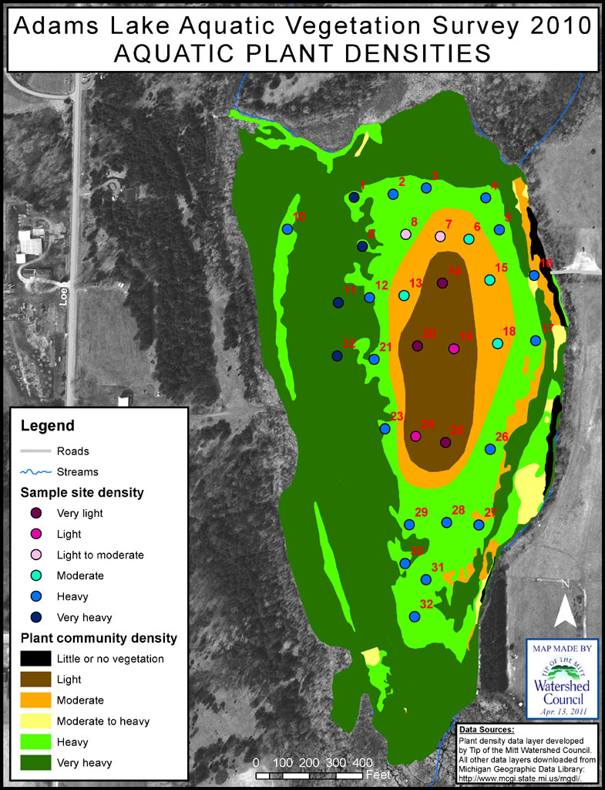

Plant community mapping results:
Aquatic plant community mapping showed that almost all of Adams Lake (99%) contained vegetation (Figure 2). The lake area with little or no aquatic vegetation was limited to half an acre (Table 5). Approximately equal percentages of the lake’s surface area were dominated by emergent vegetation (bulrush, cattails, pond-lilies, etc.) versus submergent vegetation (muskgrass, pondweed, naiad, etc.).

Table 5. Dominant vegetation type statistics.
Dominant Vegetation Type | Lake Acres | Percent
Little or no vegetation | 0.53 | 1.09
Submergent | 19.90 | 41.21
Emergent | 20.89 | 43.27
Mixed Emergent & Submergent | 6.97 | 14.43
TOTAL | 48.28 | 100.00

Coontail, pond-lily, and muskgrass were found to commonly dominate the plant communities of Adams Lake. Coontail-dominated plant communities were the most extensive, covering 9.5 acres of Adams Lake, while pond-lily and muskgrass dominated an additional 8.5 acres each (Table 6). Much of the remainder of the lake was co-dominated by a mix of aquatic plant species (Figure 3).
A vast majority of the aquatic plant communities of Adams Lake contained heavy-density growth. Over 75% of the lake area was classified as having heavy or very heavy-density plant growth, with another 12% in the moderate-density categories (Table 7). Light-density growth was limited to 9% of the lake.

Table 6. Dominant aquatic plant community types.
Dominant Community Type | Acres | Percent
Coontail | 9.51 | 19.70
Pond-lily | 8.68 | 17.97
Muskgrass | 8.52 | 17.64
Mixed emergents | 6.03 | 12.49
Bulrush, hardstem and softstem | 4.66 | 9.65
Mixed submergents and emergents | 3.69 | 7.64
Pond-lily and pondweed | 2.58 | 5.33
Cattail | 1.41 | 2.93
Mixed submergents | 0.93 | 1.92
Bulrush, swaying | 0.70 | 1.45
Pondweed | 0.69 | 1.43
Watermilfoil | 0.18 | 0.38
Sedge | 0.11 | 0.22
Pondweed and watermilfoil | 0.05 | 0.10
Iris | 0.02 | 0.04
Naiad | >0.01 | >0.01
Little or no vegetation | 0.53 | 1.09
TOTAL | 48.28 | 100.00

Table 7. Aquatic plant community densities.
Plant Community Density | Acres | Percent
Little or no vegetation | 0.53 | 1.09
Very light | 4.32 | 8.95
Light | 0.00 | 0.00
Light to moderate | 0.00 | 0.00
Moderate | 5.15 | 10.67
Moderate to heavy | 0.82 | 1.69
Heavy | 11.94 | 24.73
Very heavy | 25.52 | 52.87
TOTAL | 48.28 | 100.00

Figure 3. Map of aquatic plant community types in Adams Lake.
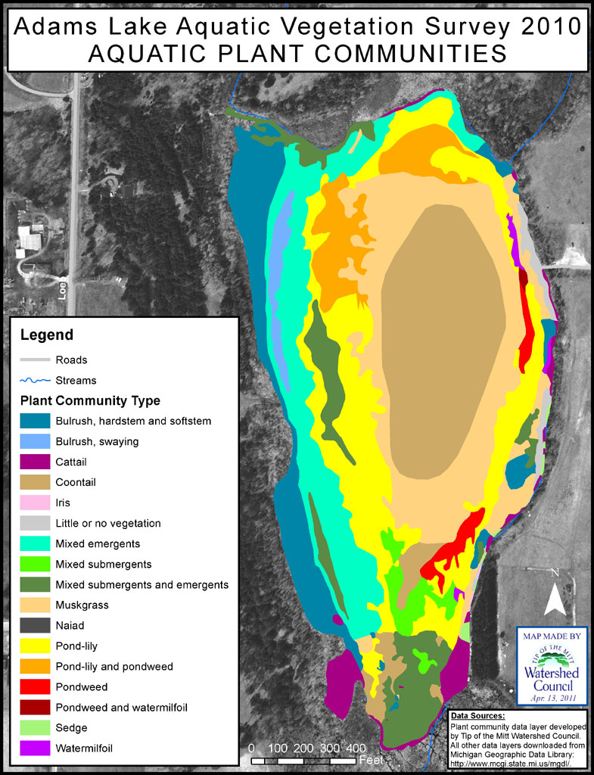

DISCUSSION

General
Survey results revealed that Adams Lake contains a diverse assemblage of native plant species, which densely populate most of the lake. In terms of surface area, over 99% of the lake is vegetated and 75% of the lake contains heavy-density growth. A total of 27 aquatic plant taxa were documented during the survey, which ranks Adams Lake in the middle for aquatic plant diversity in lakes surveyed by the Watershed Council (Table 8). Adams Lake also ranks in the middle in terms of averaged diversity across all sample sites (4.9 taxa/site).

Table 8. Aquatic plant survey statistics from area lakes.
Lake name | Acreage | Maximum depth (ft) | Percent with vegetation | Number of total taxa | Number of taxa/site
Adams | 43 | 18 | 99% | 27 | 4.9
Black | 10,133 | 50 | 13% | 32 | 3.7
Crooked/Pickerel | 3,447 | 70 | 46% | 31 | 2.4
Long | 398 | 61 | 24% | 26 | 2.8
Millecoquin | 1,116 | 12 | 95% | 20 | 6.0
Mullett | 17,205 | 144 | 19% | 42 | 3.1
Paradise | 1,947 | 17 | 58% | 24 | 5.0
Wycamp | 689 | 7 | 83% | 35 | 4.9

Generally, water depth and prevailing winds are key determinants of vegetated versus non-vegetated lake areas, which to some extent are apparent in Adams Lake. In other, deeper lakes surveyed by Tip of the Mitt Watershed Council, it has been found that aquatic plants are usually limited to 20 feet of depth and less. In the case of Adams Lake, the entire lake is less than 20 feet deep, which helps explain the abundant vegetation throughout the lake, though the deeper areas did contain light-density vegetation (Figure 2). As evidenced in aquatic plant surveys on other lakes, prevailing winds in this region from the northwest tend to create lightly or non-vegetated areas in the eastern and southeastern sides of lakes (as a result of wind and wave action). This pattern was apparent in a limited area on the northern portion of the east shoreline, where little vegetation was found.
The heavy-density aquatic plant growth throughout much of Adams Lake is likely due, in part, to natural factors; namely the small size of the lake coupled with extensive shallow areas. All lakes undergo a natural aging process, wherein they gradually fill with sediments, become more biologically productive, and eventually transform into a wetland ecosystem before disappearing completely. With less than 50 acres of surface area and 18 feet of depth, Adams Lake seems to be well into advanced stages of the aging process; it’s becoming smaller, shallower, and more biologically productive. In limnological terms, it would generally be categorized as a eutrophic (highly productive) lake that is approaching the end of its life span, though lakes age slowly and many centuries likely remain for Adams Lake.
Another variable that may be affecting the Adams Lake ecosystem is beaver activity. A lake resident reported that beavers built a dam near the outlet from Adam’s Lake on Loeb Creek. Apparently, the beaver dam caused water levels to rise, which is evident in a line of dead cedar trees that line the periphery of the lake. If the flow of water out of the lake has been dramatically reduced, then the residence time of water flowing into the lake from the inlet streams would increase and potentially result in more nutrients being deposited in the lake. An increase in lake levels would increase the volume of water, which would help dilute the lake’s nutrient concentrations. However, the dilution effect might be offset by an influx of nutrients from areas re-inundated by rising water levels where potentially large stores of nutrients were tied up in decomposing organic matter. Any increase in nutrient availability could spur on additional plant growth.
Other (not natural) factors that typically cause changes in plant growth include aquatic plant management efforts, nutrient pollution, and ecosystem changes caused by non-native species. Considering that there is no documentation of aquatic plant management efforts on the lake and that no invasive species have yet been recorded, an increase in nutrient inputs seems the most plausible factor contributing to the dense plant growth found in the lake. Nutrient inputs from cultural (human) sources, such as fertilizers, septic leachate, and stormwater, may have increased over time, though there is not enough water quality data to substantiate such a claim. Regardless, agricultural landuse in the watershed is suspected as a nutrient source that is contributing to the prolific and dense plant growth. The land area drained by the two main inlet streams includes a considerable amount of agricultural landuse (Figure 1).
Due to a lack of historical data, it is not possible to examine trends or changes in the aquatic plant communities, water quality, or ecosystem of Adams Lake. The aquatic plant survey information and water quality monitoring data collected as part of this project provide baseline data for future trend and change analyses.

Recommendations
- Share the results of this survey. The results of this study should be widely dispersed to get a maximum return on the Association’s investment. Sharing the results with members, non-member lake users, government officials, and others will inform the public about problems occurring in the lake. An informed public will be more supportive of the Association’s efforts to manage the lake ecosystem and its aquatic plants. Furthermore, an informed public may result in behavioral changes that benefit aquatic plant management, such as reducing lake nutrient loads and preventing the introduction of non-native species.

- Develop an aquatic plant management plan. The Lake Association should consider developing an aquatic plant management plan to enhance lake management efforts over the long-term. The aquatic plant community is a vital component of the aquatic ecosystem, such that good aquatic plant management translates to good lake ecosystem management. There are a number of guides available to help your organization develop such a plan, including Management of Aquatic Plants by Michigan DEQ, Aquatic Plant Management in Wisconsin by University of Wisconsin Extension, and A Citizen’s Manual for Developing Integrated Aquatic Vegetation Management Plans by the Washington State Department of Ecology.

- Investigate potential nutrient pollution issues. Nutrient pollution can lead to excessive plant growth and should be controlled wherever and whenever possible. In particular, nutrient inputs from agricultural activity in the watershed should be evaluated and best management practices instituted where possible to reduce impacts. Furthermore, property owners around the lake and along tributary inlet streams should be encouraged to properly maintain septic systems, replace old or failing septic systems (keeping in mind that drainfield soils have a limited ability to accept and treat wastes, normally about 20 to 30 years and that the State requires a 100-feet setback from the water’s edge), reduce or eliminate fertilizer use, compost and mulch far from the shoreline, and prevent stormwater from flowing directly into the lake or streams (with rain gardens, grassy swales, retention ponds, or other methods for treating the stormwater).

- Assess beaver activity and remove dams if necessary. The beaver activity on Loeb Creek should be assessed to determine if beaver dams are preventing outflow from Adams Lake. If beaver dams are causing a large reduction in the lake’s outflow, then measures should be taken to remove the dam(s) or install a bypass. However, keep in mind that taking such action will probably lower the lake level, decreasing average depths, exposing shallow areas, and ultimately resulting in a decrease in surface area for the lake.

- Preserve the lake ecosystem and natural diversity. Nuisance aquatic plant growth is an issue of concern for many shoreline residents and other lake users. However, most of the vegetated lake area contains a diverse, vibrant, healthy aquatic plant population. With regards to plant management and control options, the lake association should strive to protect the diverse assemblage of plants present in the lake, which are critical for sustaining a healthy fishery and maintaining a healthy aquatic ecosystem.

- Educate and inform lake users. Human activity in a multitude of forms typically has the greatest impact on a lake’s aquatic plant communities. Therefore, effectively managing the lake’s aquatic plants requires information and education outreach projects that target shoreline property owners, watershed residents and all lake users. Residents can improve land management practices to reduce nutrient loading (to control excessive plant growth) by establishing naturally vegetated buffers along the shoreline or streambank, reducing or eliminating yard fertilizers, and properly maintaining septic systems. Lake associations can help prevent the introduction of non-native species (such as Eurasian watermilfoil, which is becoming more common in Northern Michigan) by posting signs and educating members and other lake users. Outreach activities should not be limited to dos and don’ts, but also include general information about aquatic plants and their importance to the lake ecosystem.

- Regularly survey the aquatic plants of Adams Lake. To effectively manage the aquatic plant community of Adams Lake, periodic aquatic plant surveys should be conducted. Future surveys will provide data for determining trends over time, evaluating successes or failures of aquatic plant management projects, and for early detection of and rapid response to effectively control non-native aquatic plant species. Although dependent upon many different variables, surveying the aquatic plant community on a 5-10 year basis is generally sufficient.

LITERATURE AND DATA REFERENCED

Charlevoix County GIS Department. 2004. Digital Orthophotography 1:400. Charlevoix, MI. http://www.charlevoixcounty.org/gis.asp

Crow, G. E. and C. B. Hellquist. 2000. Aquatic and Wetland Plants of Northeastern North America. The University of Wisconsin Press. Madison, WI.

Gibbons, M. V. and H. L. Gibbons. 1994. A Citizen’s Manual for Developing Integrated Aquatic Vegetation Management Plans. Washington State Department of Ecology. Olympia, WA. http://www.ecy.wa.gov/biblio/93093.html

Korth, P. A. et al. 2007. Aquatic Plant Management in Wisconsin. University of Wisconsin Extension. Stevens Point, WI. http://www.uwsp.edu/cnr/uwexlakes/ecology/APMguide.asp

Michigan Department of Environmental Quality. 2001. Management of Aquatic Plants. Lansing, MI. http://www.deq.state.mi.us/documents/deq-ess-caap-workshop-land-water-MgmtofAquaticPlants.pdf

Michigan Department of Environmental Quality. 2001. Procedures for Aquatic Vegetation Surveys. Lansing, MI. http://www.deq.state.mi.us/documents/deq-water-ilm-ProceduresForAquaticPlantSurveys.pdf

Michigan Department of Information Technology, Center for Geographic Information. 2009. Michigan Geographic Data. Lansing, MI. http://www.mcgi.state.mi.us/mgdl/

Michigan Department of Natural Resources. 2009. Inland Lake Maps. Lansing, MI. http://www.michigan.gov/dnr/0,1607,7-153-30301_31431_32340---,00.html

National Oceanic and Atmospheric Administration, Coastal Services Center. 2006. Coastal Great Lakes Land Cover Project. Charleston, SC. http://www.csc.noaa.gov/crs/lca/greatlakes.html

Unites States Geological Survey. 1990. 1/100,000 Topographic Maps. Reston, VA.

